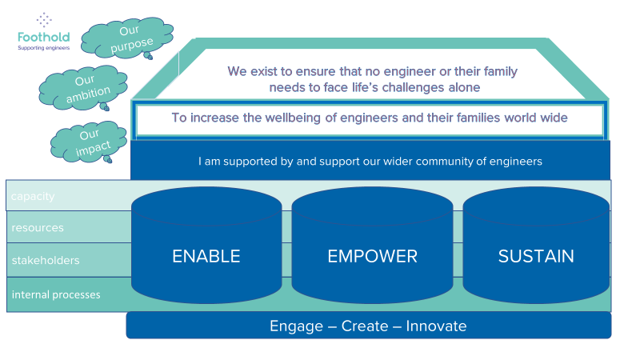
Our strategic framework
ENABLE our community to participate in a socially inclusive lifestyle
- achieving a household income of 75% of MIS level for eligible community members
- amplifying voices of organisations advocating for social change around poverty and associated issues
EMPOWER our community to increase their resilience to life’s challenges
- creating connected communities
- developing digital health and wellbeing offers
- engaging with new partners to widen our scope
- creating positive change by developing our understanding of the equality, diversity, and inclusion issues and how we can address them
- being a barometer for the health and wellbeing of our engineering community
SUSTAIN support for and from our community
- engaging our community with our purpose
- increasing our voluntary income
- maintaining expenditure within budget
- creating innovative models of volunteering
Our strategic objectives

Our beliefs

