Fundraising & Marketing Officer
Recruitment Pack

August 2021

Our story
We may not know much about engineering, but we do know engineers. We’ve been supporting IET (Institution of Engineering and Technology) members and their families since 1890.
We understand people and we understand how life can be at work and at home. It’s unpredictable, complex, demanding.
Amidst the busyness of our lives we often forget that being well is just as important as doing well.
More of us are feeling stressed in our jobs. One in four of us will have a mental health problem this year. More of us are living longer. Our health needs are growing yet we have a shortage of carers. Rising costs are forcing living standards down. And we’re facing a loneliness epidemic.
We all need to start taking better care of one another, because we all need a little support from time to time. Even engineers.
We wanted to know how we could do more, so we asked our community of engineers. Seven out of ten engineers worldwide said they wouldn’t ask for help even if they needed it. Yet they told us there isn’t enough support out there for day-to-day problems, let alone a crisis.
We’re here so engineers and their families never need to face life’s challenges without support. We want engineers across the world to feel supported in all aspects of their lives and to feel that it’s OK to ask for that support. We want them to be healthy and able to stand on their own two feet. We want them to feel looked after but also empowered by their professional community.
Funded by engineers, for engineers, Foothold is here for engineers and the people who matter to them most. Whatever the problem, big or small.
Foothold is a starting point, giving engineers the tools to make their life better right now.
Foothold is a network of skilled individuals who’ll listen to problems in confidence. It’s a source of options to help engineers meet their needs emotionally, physically, and financially.
Foothold is a place to regain balance and help others do the same. Foothold is here.

Our challenge
In 1890 a group of engineers decided that their Institution should do something for fellow engineers in need. In the almost 130 years since we have continued to develop services which support almost 1,000 engineers and family members a year, from across the globe.
And now as Foothold, The Institution of Engineering and Technology benevolent fund, we exist to ensure that no engineer or their family needs to face life’s challenges without support and with 168,000 current members of the Institution of Engineering and Technology and many previous members spread across 150 countries this is a challenge.

Our vision is to increase the wellbeing of engineers and their families worldwide. Our targets are stretching to meet the growing needs of our community, so we’re now investing in our fundraising resource to help us meet this challenge. We’ve reshaped our fundraising, marketing and communications functions and are now looking for talented fundraising and marketing professionals to join us.
We are a small team who want to make a big impact. If you think that you have the skills and experience we need and are excited by the opportunity to join a thriving forward looking team we’d love to hear from you.
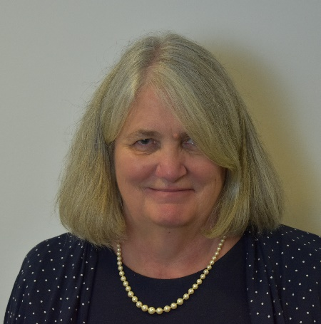

Jane
Jane Petit
CEO

Our beliefs

Every call for help must be heard - we have a social duty to care about each other – as human beings. Any need no matter how big or small, is worthy of our support. Nobody should have to face life’s challenges alone.
Asking for help takes courage - we all need support from time to time - even the most capable among us. It takes strength to accept our own vulnerability. Nobody should feel ashamed to ask for help

The best support empowers - support is at its best when it puts people in the driving seat. When a person has the right tools to change their life, they’re more resilient to adversity strength to accept our own vulnerability. Nobody should feel ashamed to ask for help.

A problem shared is a problem halved - we can overcome challenges - together. Being part of a community means we’re there to support and empower one another

Our commitments
We’re empathic - we seek to understand needs as if they were our own. Through empathy and understanding we truly support.
We’re joined-up - we’re here to support with all aspects of life, and to help increase all-round wellbeing. People’s needs are connected, so our support must be too.
We’re trusting - we treat people as equals. Building relationships based on trust allows us to provide better, quicker support.
We’re open-minded - we listen without prejudice and act without discrimination. No challenge is too big or small.
We’re encouraging -we want people to feel able to stand on their own two feet. To feel they can make positive choices and changes in their life
We’re bold - to offer meaningful support, we must break down stigma, address the big issues and try new ideas without fear of failure.

Our strategy

Why our help is important
Our research showed that our community have three main areas of need:
- Work and employment
- Health and wellbeing
- Financial and legal problems

Our new strategy focuses on activities which support an increase in wellbeing, intended to empower our community by providing tools to help them help themselves.

Then, if engineers and their families experience life events and moments of transition such as getting sick, experiencing bereavement, redundancy or relationship breakdown (all common triggers for poverty) not only can we offer practical assistance with finances or legal matters, we have also increased their likelihood of coping.

Our strategic framework
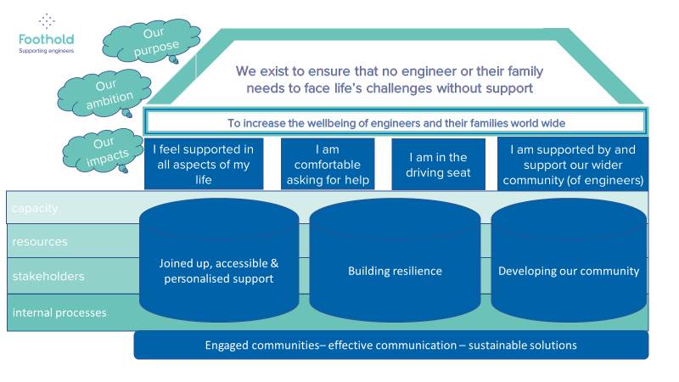
Foothold Organogram

Board and Committee structure

Audit and investment committee
4 meetings a year

Service development committee
3 meetings a year

Disciplinary committee
As required

Remuneration committee
As required

Triage Advisor
JOB DESCRIPTION
Organization | Foothold (The IET Benevolent Fund)
Job title | Fundraising & marketing officer
Location | Flexible remote with presence at our office in Holborn for team meetings
Reports to | Fundraising and communications manager
Hours | Permanent - 35 hours a week (flexible working- core hours Tuesday 10-11 am)
Salary | £29,000pa

Primary purpose: | To develop successful relationships with supporters and stakeholders across Foothold maximising awareness, income and opportunities.  To plan and manage fundraising and marketing activities through to the analysis of campaigns, identifying ways to increase conversion, retention and average gift.  To contribute to and support the delivery of the fundraising, communications, and marketing strategies.

Key tasks

- Lead and manage specific fundraising and marketing activities as directed by your line manager, working to reach and exceed targets where possible
- Contribute to the annual budget setting, phasing and reforecasting programme, providing financial information to your line manager as requested
- Create fundraising specific content for the website, social media, digital campaigns and email marketing working collaboratively with the communications officer to ensure brand compliance
- Implement and monitor marketing and fundraising plans for your specific areas of fundraising responsibility
- Support the creation and implementation of supporter journeys to a sector-leading standard that creates an unparalleled supporter experience
- Work with the supporter care officer to oversee the thanking programme ensuring each donor receives a high quality, personalised thank you in line with agreed timescales
- Build successful relationships with charity partners, supporters, matching interests and motivations to opportunities to support Foothold
- Represent Foothold at ad-hoc events in the community, giving talks and presentations about the work of Foothold and how people can support us
- Work with the supporter care officer to oversee the impact reporting programme ensuring donors receive high quality feedback on the impact of their donation
- Build and manage successful relationships with fundraising suppliers and partners
- Work collaboratively with the other members of the fundraising & marcomms team to achieve team goals and further the mission of Foothold

- To produce reports which evaluate and review fundraising activity, and support on the development of new initiatives to maximise income and supporter involvement

- Proactively stay up to date with emerging trends and developments in charities, fundraising and marketing, harnessing new ideas and concepts to drive forwards Foothold’s mission

General
- Attend regular supervision, team and staff meetings
- Undertake mandatory training as required by Foothold
- Take responsibility for Health and safety of yourself, your colleagues and your environment
- Ensure confidentiality of records and information is maintained in accordance with Foothold’s Confidentiality Policy and Data Protection policy GDPR
- Undertake any other tasks as identified by your manager or the CEO

Fundraising & Marketing Officer/Executive Person Specification
Criteria | Essential | Desirable
Experience
Experience working within a fundraising/marketing environment, collaborating with colleagues to achieve individual and team targets
Experience of building and developing successful relationships with supporters, partners and suppliers
Experience of leading on/project managing campaigns and appeals to achieve targets
Education and qualifications
No specific qualification is required, but evidence of recent continuing professional development in an area relevant to the post will be required
Skills & abilities
Demonstrate ability to motivate and inspire individuals, businesses and groups to support Foothold
Demonstrate understanding of what makes exceptional supporter care
Confident communication and presentation skills with an ability to adjust tone and content for different audiences and able to work within brand and tone of voice guidelines
Ability to think creatively, offering new ideas, concepts and solutions
Ability to work sensitively with Foothold community members to gather stories and testimonials
Effective time management skills in order to meet competing priorities and deadlines
Ability to troubleshoot difficult situations, and deal with them calmly, diplomatically efficiently and effectively
Ability to work effectively as a member of a small team
Competent user of Microsoft Office applications, excel and CRM systems
Knowledge
Up to date knowledge of current fundraising legislation and GDPR
Knowledge of website content management systems eg. Wordpress
Up to date working knowledge of current fundraising and marketing practices and trends including social media, email, content and direct marketing.
Knowledge of project management systems eg. Asana
Knowledge of email marketing tools eg. Dotmailer
Personal attributes
A proactive, self-motivated and positive approach to work
Commitment to the core values and ethos of Foothold

A willingness to work flexibly with colleagues on other specified duties or projects as appropriate
Commitment to the highest standards of donor care
A willingness to undertake training for further development
A willingness to work occasional evening/weekend hours in return for time off lieu
Commitment to anti-discriminatory practice and equal opportunities and an ability to apply awareness of diversity issues to all areas of work

How to apply
Please send your CV and supporting statement outlining your interest in the post and how you meet the points in the person specification. Please also give the names of two referees who we will contact once an offer of employment has been made.
Applications should be submitted to fliss.rook@myfoothold.org by 11am on Monday 23rd August.
Interviews will be held in the week commencing 23rd August.
For a confidential discussion about the role please email fliss.rook@myfoothold.org to arrange a time.

To find out more about Foothold visit our website myfoothold.org

